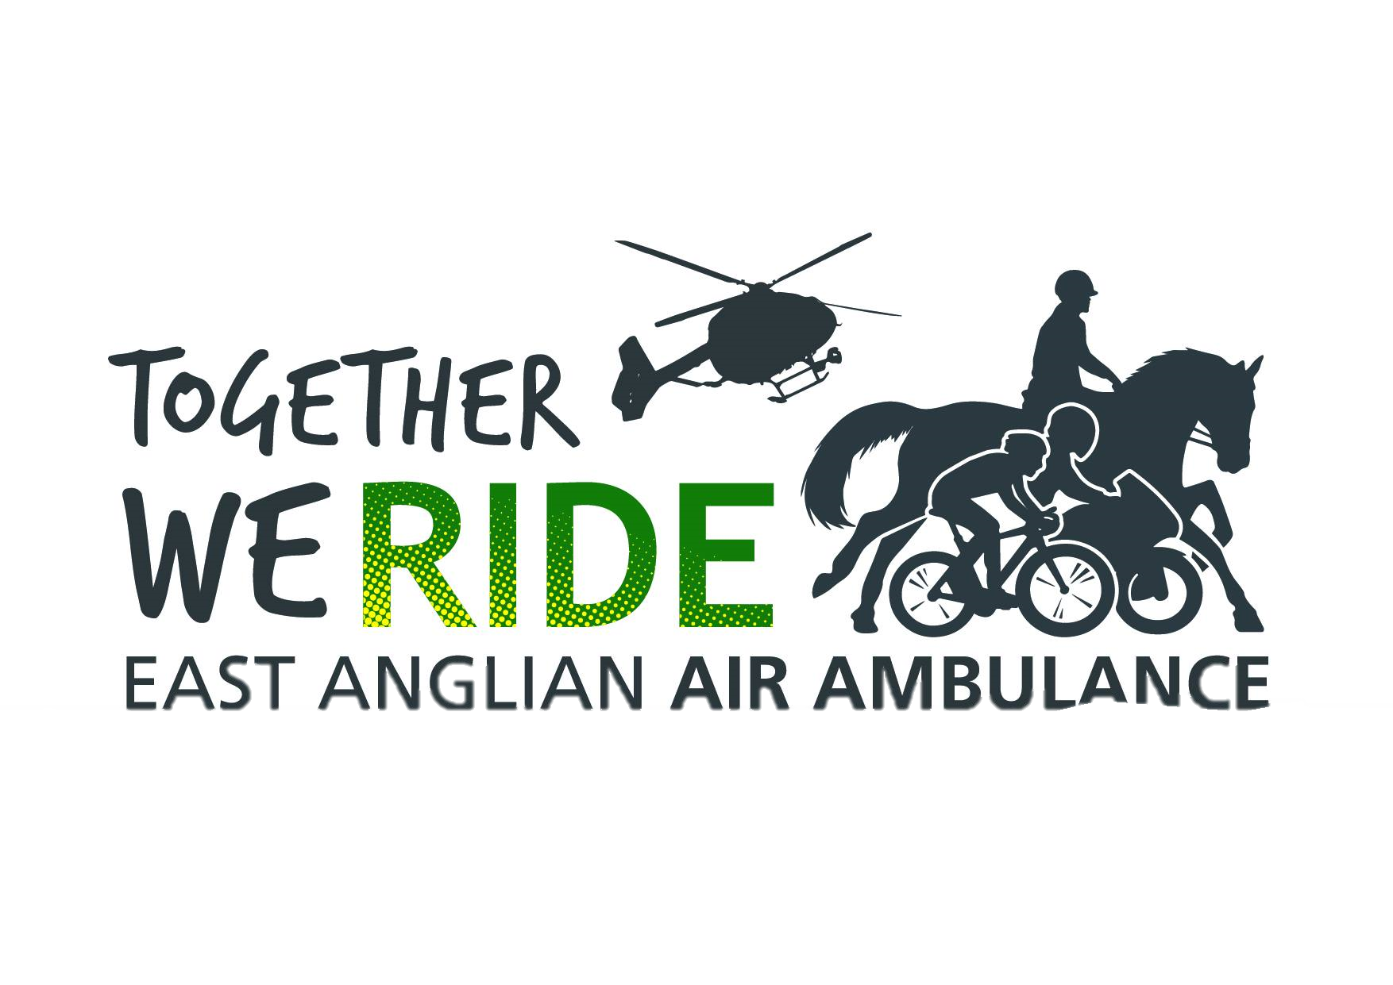Hedley’s 900 Miles A Chair and A Bear
In August Hedley rode 969 miles, for E.A.A.A. raising £3632.
The ride took him up the west side of E.A.A.A, normal operating area (Bedfordshire, Cambridgeshire, Norfolk, & Suffolk), and NW to Kings Lynn and round the coast to Wells Next the Sea, then back home, for five days’ rest, having completed the first 300 miles
The second 300 miles took him across the South of the operation area to Felixstowe up to Lowestoft, and back home for 5 days again.
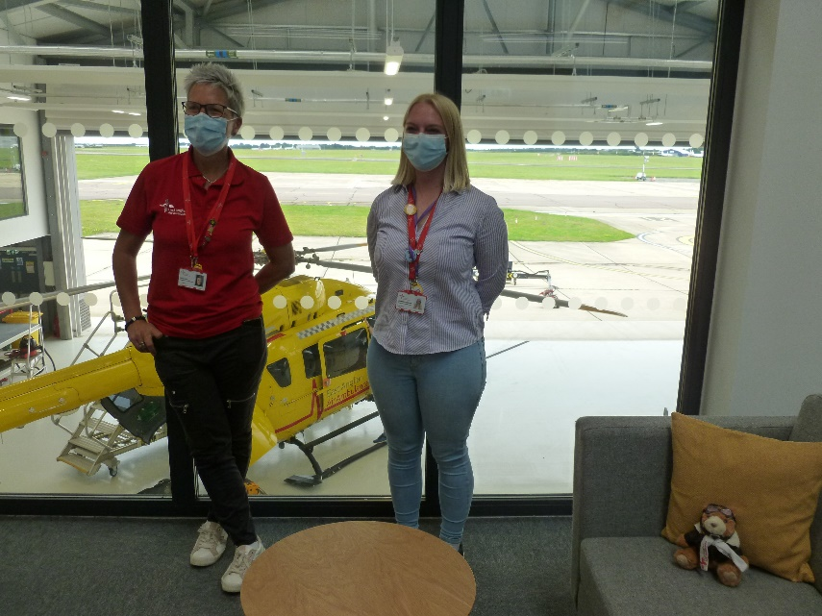
The third ride Hedley had the companionship of David White A member who has moved to Lincolnshire, the route went to Norwich for a visit the helipad. When they arrived most of the staff were outside cheering, and clapping, and buffet of cycling fuel (Including Cake). The Photo shows hosts Zoe & Lauren, in lounge overlooking the hanger.
the picture you will find Pilot Ted, and in all pictures.
After Norwich over to east coast at Yarmouth. The bike on the rails on the Promenade, while ice creams were consumed. Then home, 306 miles,
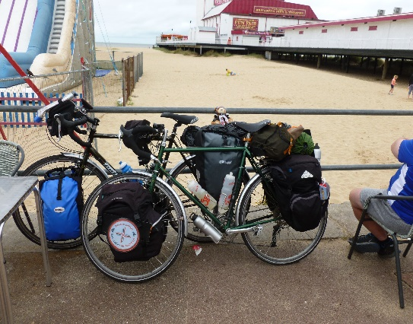
Each bike with kit weighed more than 40 kilograms

David’s Heroic Ride.
David bike had a catastrophic failure, A few miles on from Burt St. Edmonds. Was it the chain or rear mehc.? The rear mehc. was bent into the spokes, the chain was broken two spokes. Jury rigged the chain in middle gear (middle front chainwheel, middle rear sprocket), vertical rear dropouts, would not allow tensioning the chain.
David rode 76 miles only having only to walk on one hill when his chain jumped to a higher gear, then he was unable to restart.

Each day was like a board game, there was snakes and lots of rules not many ladders but some advances. The riding went like this, miss a turn, go down a snake, go back 5 miles, climb up a snake, take a short Scottish holiday, lose 5 minutes, check the treasure map lose 10 minutes The ladders & advances came when you were not traveling. The ladders, the people I met and the kindness shown, that lifted moral, the advances were the donations to E.A.A.A.

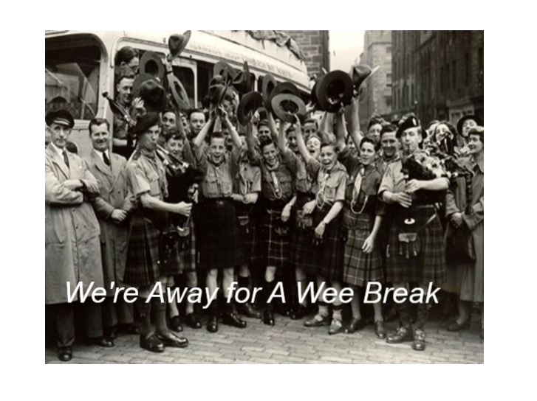
An affair: After riding from Lowestoft to Bury St Edmunds, into the wind, my exhaustion was showing. The site that was at Whepsted four mile to the south of Bury. Mr. and Mrs Harris were my hosts, showed me to my pitch. Rolled out my tent, and Mr. and Mrs. Dean & Karen Harris were back, “Our Hetty hasn’t any customers tonight, Would you like her tonight?” I jumped at the chance, (wouldn’t you?). I slept in her bed, sampled her comforts and charms, a night to remember.

Each day was like a board game, there was snakes and lots of rules not many ladders but some advances. The riding went like this, miss a turn, go down a snake, go back 5 miles, climb up a snake, take a short Scottish holiday, lose 5 minutes, check the treasure map lose 10 minutes The ladders & advances came when you were not traveling. The ladders, the people I met and the kindness shown, that lifted moral, the advances were the donations to E.A.A.A.


An affair: After riding from Lowestoft to Bury St Edmunds, into the wind, my exhaustion was showing. The site that was at Whepsted four mile to the south of Bury. Mr. and Mrs Harris were my hosts, showed me to my pitch. Rolled out my tent, and Mr. and Mrs. Dean & Karen Harris were back, “Our Hetty hasn’t any customers tonight, Would you like her tonight?” I jumped at the chance, (wouldn’t you?). I slept in her bed, sampled her comforts and charms, a night to remember.

An affair: After riding from Lowestoft to Bury St Edmunds, into the wind, my exhaustion was showing. The site that was at Whepsted four mile to the south of Bury. Mr. and Mrs Harris were my hosts, showed me to my pitch. Rolled out my tent, and Mr. and Mrs. Dean & Karen Harris were back, “Our Hetty hasn’t any customers tonight, Would you like her tonight?” I jumped at the chance, (wouldn’t you?). I slept in her bed, I sampled her comforts and charms, a night to remember.
*
*
*
*
*
* MEET HETTY
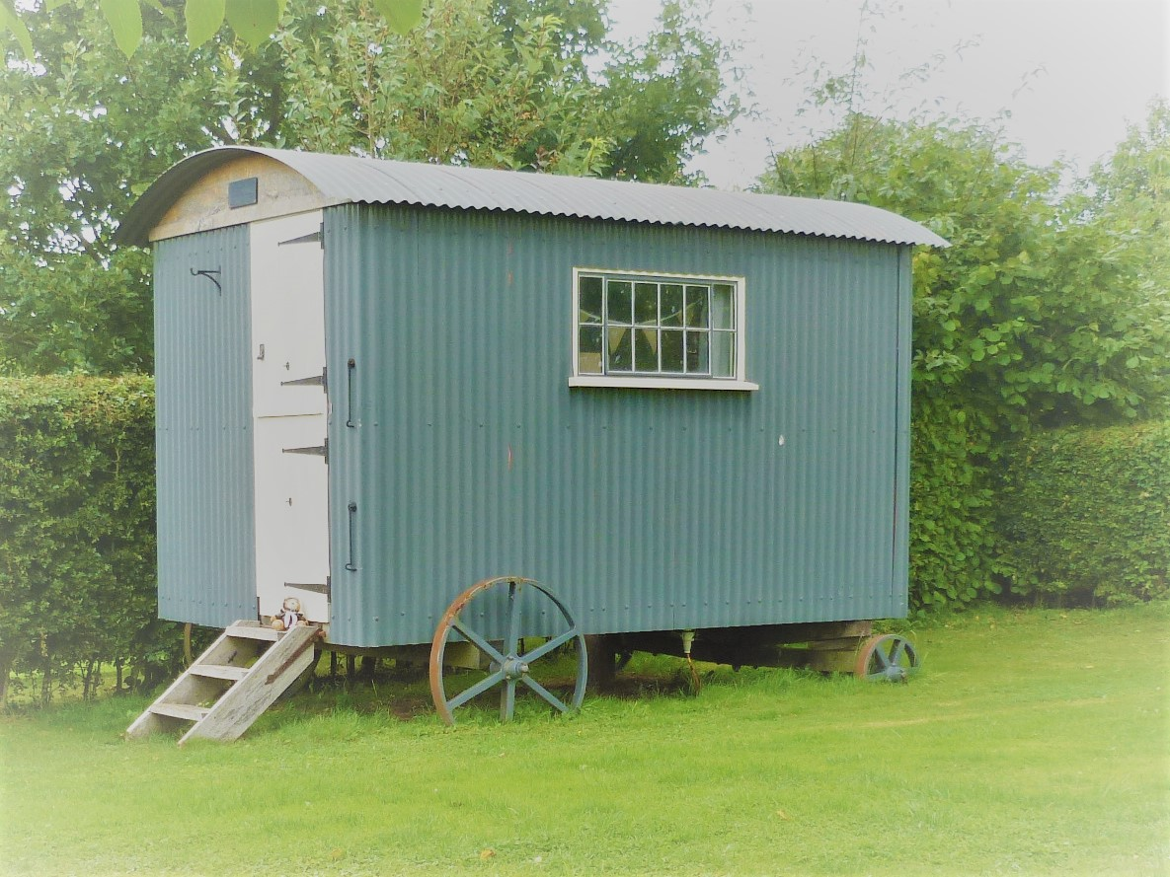

THANKS TO ALL THOSE THAT HAVE DONATED!
MUSESINGS: The total £4632 is very good, as it covers the average cost of a mission, BUT one mission out of an potential 3000 Missions a year. Where do we find another 2,999 people to do likewise? Fortunately, many, many, people do drip feed the A.E.E.E.
DOES THAT MAKE ME A BIG DRIP? (I don't really want an answer to that question)

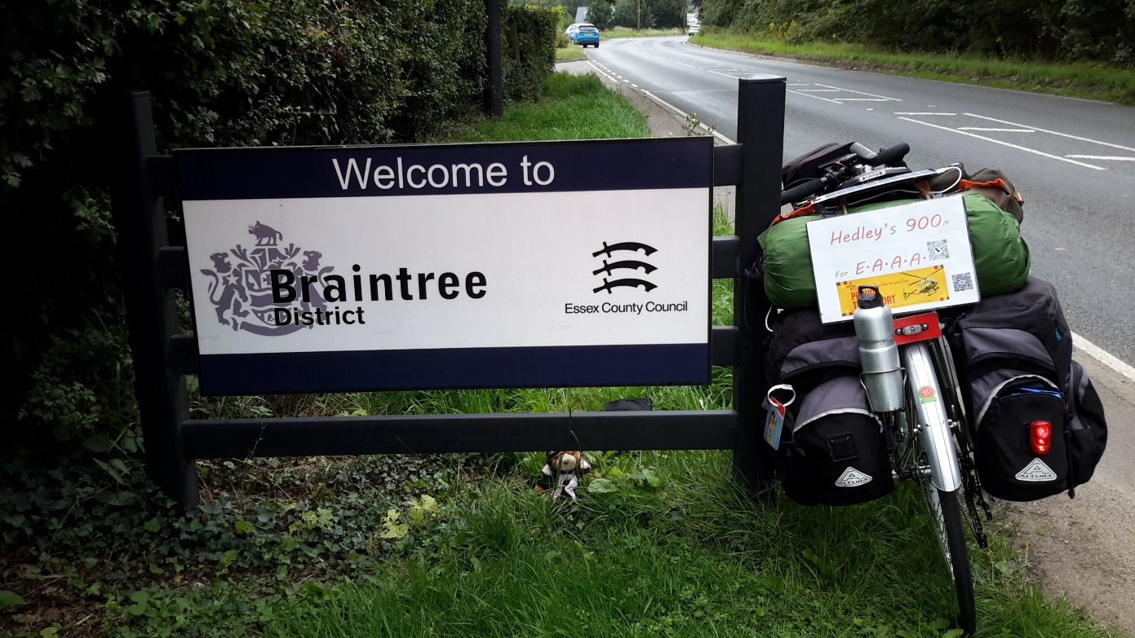
Why is Braintree significant?
I cycle tour, this year I had no plans, my time taken up by trying to wind up my brother’s affairs. He died Philippines, a long story, that caused lots of complications. In July East Anglian Air Ambulance emailed their latest fundraising challenge “We Ride Together”. Ready for a physical challenge after a mental one, select 30, 100, or 300 miles, in August. The boarders of the normal operation, Bedfordshire, Cambridge, Norfolk, and Suffolk, county boarders, and coast equal 900 miles, so signed for 900 miles
I was born (nothing new in that) 1950, a resus baby, and premature. The only man of the. cloth in hospital was a Roman Catholic Priest. The last rights were read, well I’m still here. There is debt to all of the medical professionals, I owe even to these new kids on the block.
The plan, 3 x 300 mile rides, six days on road, five at home, six out five back, six out, averaging 50 miles a day, visiting places near the boarders. Transport a bicycle (not an e-bike) with camping kit and luxuries, a comfort mattress, and a chair, total weigh 46kg. Ted, my constant companion, (Pilot Ted my Mother in law’s, she was known as Nana to all Toddington 41’ers as she had taken the number, & menu choices for our meetings for many years.) Out of the fifteen nights camping, camped on twelve different sites, one for two nights, and Cambridge Camping & Caravan Club site for three separate nights. Seven nights camped free of charge, I was self-funding, so any camp fees not paid, were paid to E.A.A.A.
I cycle tour , this year I had no plans, my time taken up by trying to wind up my brother’s affairs. He died Philippines, a long story, that caused lots of complications. In July East Anglian Air Ambulance emailed their latest fundraising challenge “We Ride Together”. Ready for a physical challenge after a mental one, select 30, 100, or 300 miles, in August.
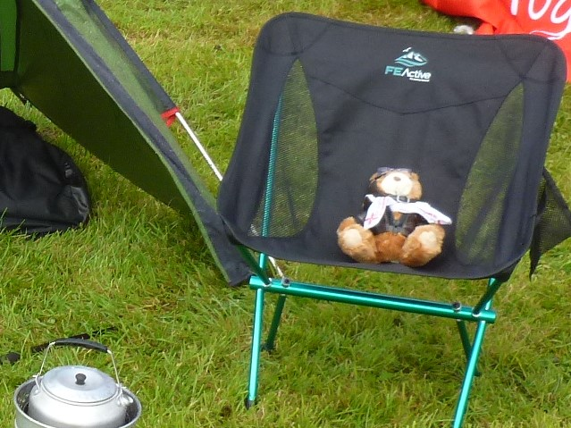
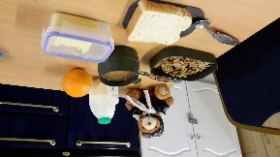
Pilot Ted trying to eat my breakfast. Pilot Ted creeps into all the pictures, but travels crushed down the side of a cool bag in a front pannier.
Each day was like a board game, there was snakes and lots of rules not many ladders and no advance spaces or miles. The ladders & advances came when you were not traveling. The ladder the people I met and the kindness shown, that lifted moral, the advances were the donations to E.A.A.A.
Riding went like this, miss a turn, go down a snake, go back 5 miles, climb up a snake, take a short Scottish holiday, lose 5 minutes, check the treasure map lose 10 minutes
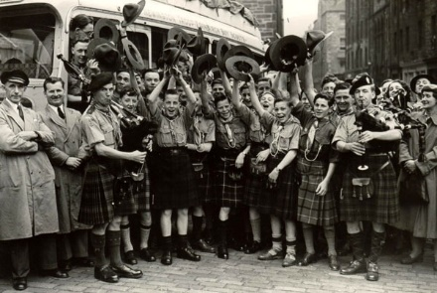
We’re going for Wee Break

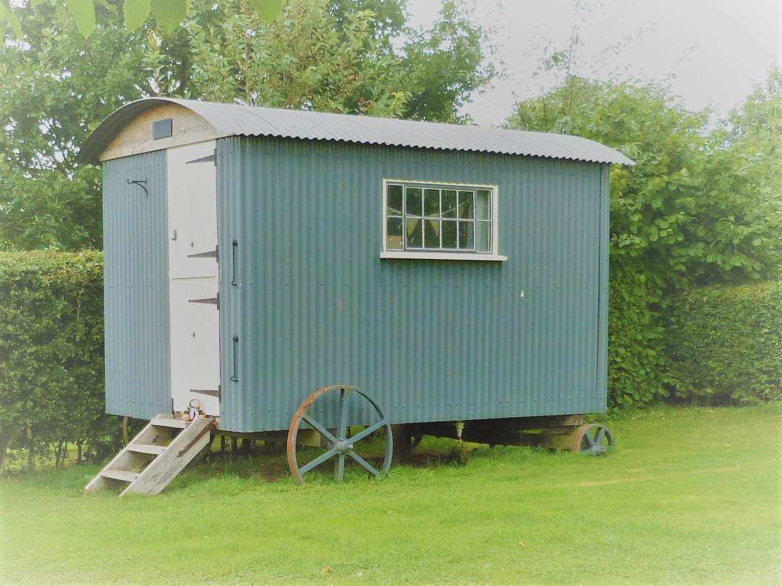
Meet Hetty



An affair: After riding from Lowestoft to Bury St Edmunds, into the wind, my exhaustion was showing. The site that was at Whepsted four mile to the south of Bury. Mr. and Mrs Harris were my hosts, showed me to my pitch. Rolled out my tent, and Mr. and Mrs. Dean & Karen Harris were back, “Our Hetty hasn’t any customers tonight, Would you like her tonight?” I jumped at the chance, (wouldn’t you?). I slept in her bed, sampled her comforts and charms, a night to remember.
The last 300 A friend David White, joined me, the highlight, of that ride was a visit to E.A.A.A. Norfolk. We were requested to phone half hour before arriving, when we arrived all the staff were outside to cheer and clap us in, and a buffet of tea and cake (cake is petrol for bikes).
Braintree, was hoping to find the Braintree to get another better brain to stop me taking these silly challenges. Leanne and Zoe, our hosts at E.A.A.A.

Currently total raised £3025, would be good to reach the milestone of the cost of a mission £3500



